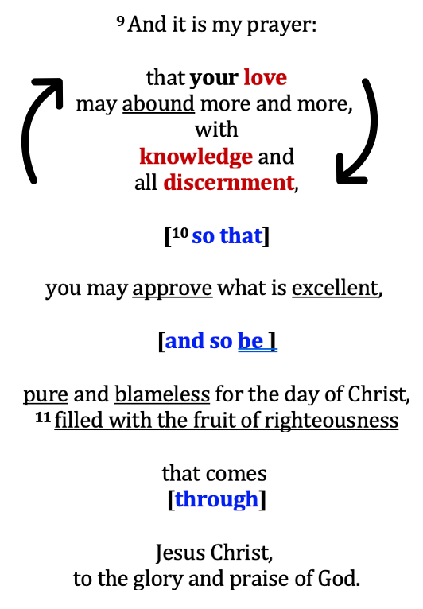
Part 1: The Petition v9

Roman 5:5 God’s love has been poured into
our hearts through the Holy Spirit

Part 2: The Purpose v10-11a

Part 3: The Power and Praise v11b

Discussion and Application:

1. Briefly describe the overall flow of the passage. What is Paul praying for in 1-2 sentences?

2. (v9) How does growing in our knowledge of God (Col 1:10-11) increase our discernment? Describe how growing in knowledge and discernment increases our love for God.

4. Think about where you were in your faith 1, or 5 or 10 years ago. How has your love for God grown and why?

5. How is v9 connected to v10? What can hinder our choices in approving what is excellent?

6. Think out loud about an unwise choice you have made. How may v9-10 be clarifying for you now?

7. How is the godly fruit of lives connected to our increasing love for God?

8. In point 3, how is the gospel functioning “through Christ” to accomplish and complete the amazing work in you and us? Why does this give you confidence?

9. How does the pursuit of Godly excellence bring glory and praise tot God?

10. (Extra credit) Is “pure and blameless” in v10 an imputed or an imparted righteousness? Explain.

