SERMON Mark 7:1-23 FROM THE INSIDE OUT T. Neumann 3/31/2019

Jeremiah 17:9 “The heart of man is deceitful above all things and desperately wicked.” KJV
Romans 3:10-11 “There’s none righteous, no, not one.”
James in 1:14 ….”deceitful desires in our hearts,
Prov 4:23 Above all else, guard your heart, for everything you do flows from it.

Point 1 Conflict Over Dirty Hands

Point 2 Its Not About the Outside!
V 14-19

Point 3 It’s All About The Heart
v 20-23

Mark 7:21 For from within, out of the heart of man…..
Matt 15:17-18 Do you not see that whatever goes into the mouth passes into the stomach and is expelled? But what comes out of the mouth proceeds from the heart, and this defiles a person.
Luke 6:45 The good person out of the good treasure of his heart produces good, and the evil person out of his evil treasure produces evil, for out of the abundance of the heart his mouth speaks.

Ezekiel 36:25-26
²⁵ I will sprinkle clean water on you, and you shall be clean from all your defilements, and from all your idols I will cleanse you.
²⁶ And I will give you a new heart, and a new spirit I will put within you. And I will remove the heart of stone from your flesh and give you a heart of flesh. ²
²⁷ And I will put my Spirit within you, and cause you to walk in my statutes….

Titus 3:5
⁴ But when the goodness and loving kindness of God our Savior appeared,
⁵ he saved us, not because of works done by us in righteousness, but according to his own mercy, by the washing of regeneration and renewal of the Holy Spirit.

Application
- Think about 1 area of your life that you find yourself worrying, anxious, impatient or irritable? Or, an area of besetting sin that you keep doing (see the list in 7:21-22).
- Slow the internal conversation down and ask: “What do I want in this moment? What am I desiring and not getting, or what am not wanting and seeking to avoid?”
- Be brutally honest “: I want ________________________.” Or “I don’t want ___________________________”.
- God has given you a new heart, the Holy Spirit in you, will never condemn you and will always forgive you.
- Pray about this one thing, confess it to God and ask Him to help you repent.
- Then ask Him to help you war against this thing, and replace it with Godliness, fruit of the Spirit and joyful obedience.
- Lastly, God doesn’t call us to do this alone. Invite someone in and walk the path of change and growth together.
Jesus’s illustration of ‘CORBAN’
(to illustrate the misapplication of ceremonial law by the Pharisees and Scribes)

7:10-13 honor your father and your mother (cf. Ex. 20:12; 21:17; Deut. 5:16). No one questions the importance of this law in the Ten Commandments; disregarding it was punishable with death in ancient Israel. Part of honoring father and mother is to care for them, both financially and personally, in their old age. However, Jewish tradition allowed that funds originally dedicated to the care of parents could be declared Corban (Hebrew/Aramaic for legally "dedicated to God"; cf. Lev. 1:2; 2:1; etc.), meaning that the person would no longer be required to do anything for ... father or mother. These funds could now be given to the temple, if so desired. Such human traditions thus allow room for the depravity of the human heart, directly opposing the | Law of Moses which so often serves to protect the weak and helpless, in this case, parents in their feeble old age (making void the word of God). The "Corban” tradition is an example (along with many such things you do) of disregarding and rejecting the more important aspects of the Mosaic law."
ESV Study Bible, p 1906-07

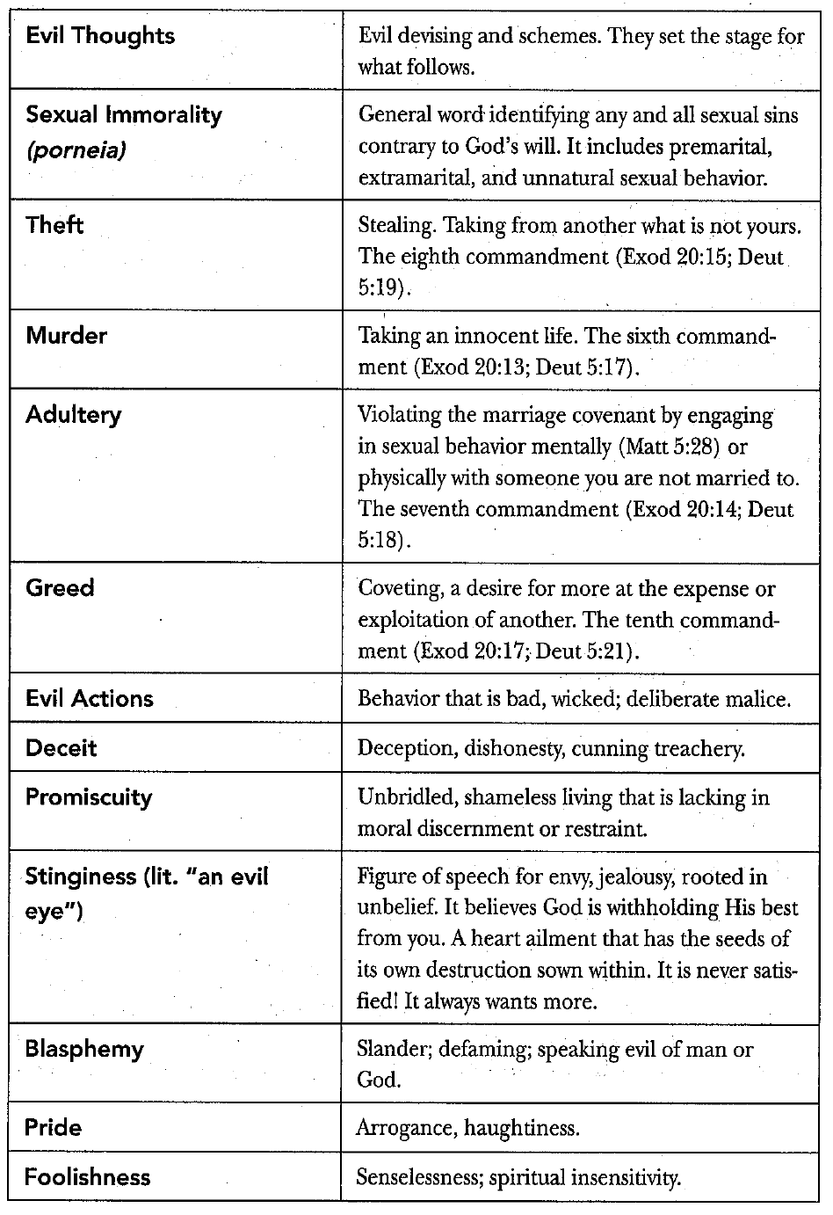
Verse 7:21-22

