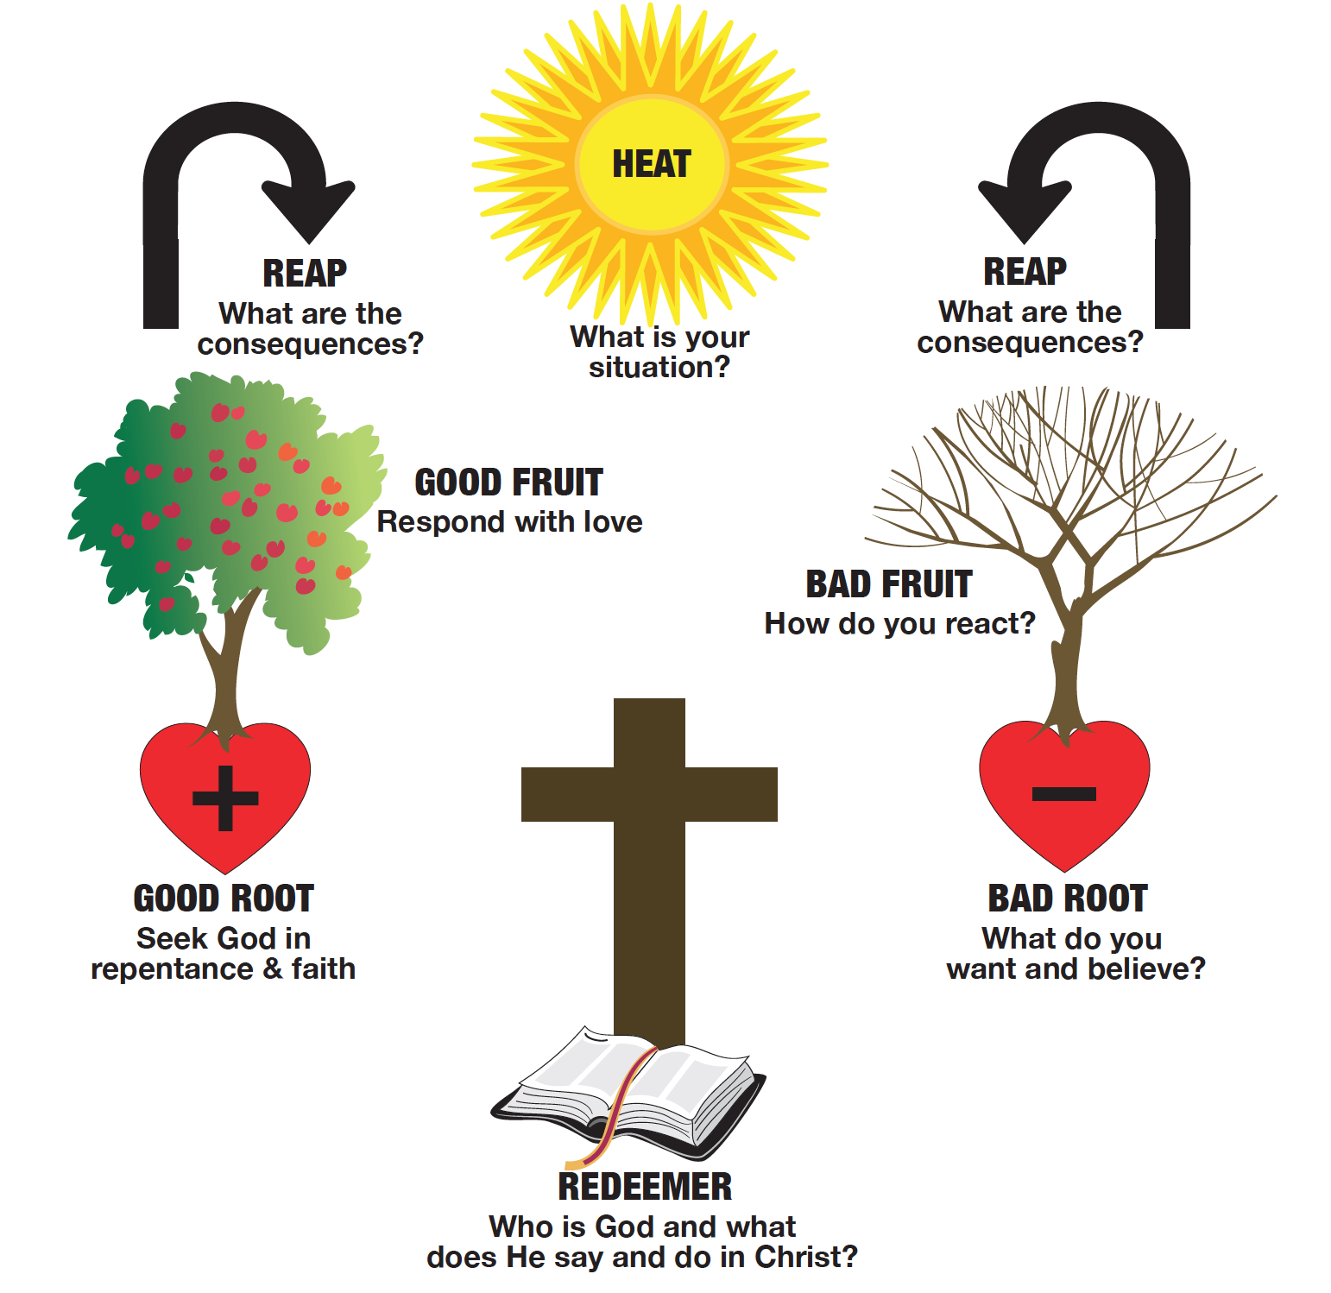
SERMON Side By Side Part 2: We Are Needy 12-9-2018

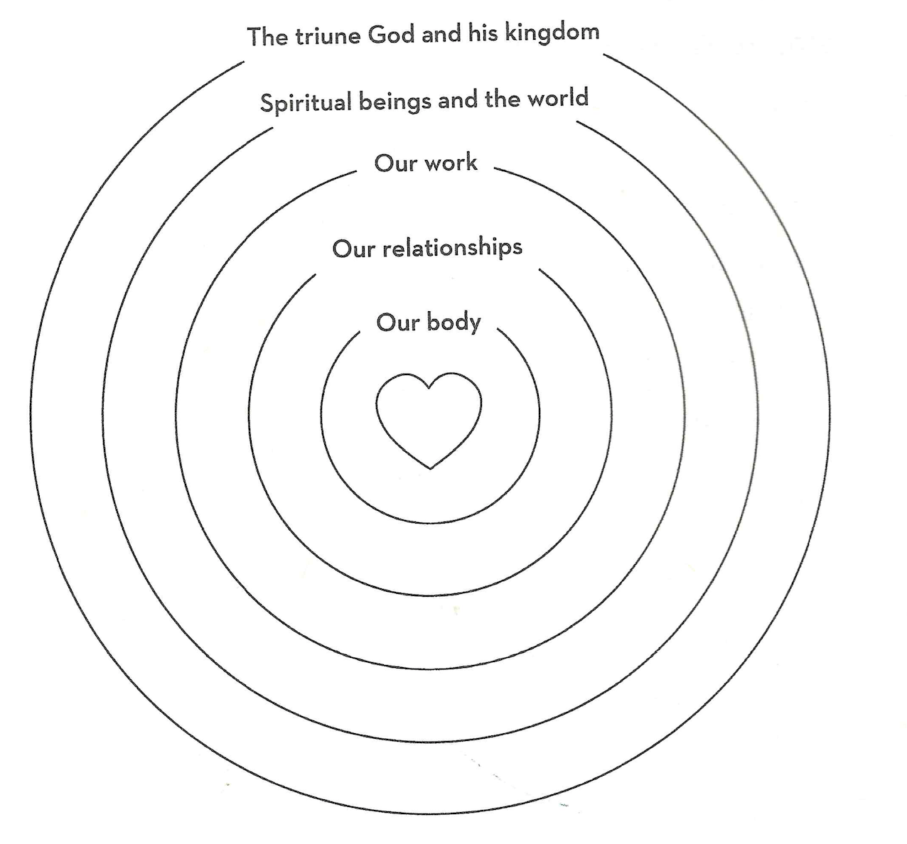
CHP 1
Chp 2

Chp 3

( See Powlison Handout).
Ps 3:3 lifter of my head/ off my circumstances to one in them
Ps 9:9-10 -stronghold in times of trouble
Ps 16:5-8 – holds my lot – good by his love governed by Hos wisdom
Ps 19:13 keep me from presumptuous sin/ no dominion over me
Ps 31:3,14-15, 24 rock fortress, times are in your hands
Ps 21:7-8 hiding place for me, instructs me, counsels me
Ps 46 no request, bout Who God is in trouble times.
Ps 56:8-9 He knows intimately what you’re going through.

From the Psalms:
1. What happened?
2. What’s it feel like?
3. Who is God?
4. What’s faith look like?

Chp 4,5,6

2Cor 12:1-10
James 4:6,10
1 Peter 5:5-7

"It is our work to cast care and it is God's work to take care.
By our immoderate anxiety we take his work out of his hand.
Care, when it either distrustful or distracting, is very dishonorable to God.
It takes away his providence, as if he sat in heaven, and
minded not what became of things here below." Thomas Watson

What would it look like for Him to meet you? That’s our request.
What would it look like for Him to meet you even though nothing changes? That’s His Character..
What is your greatest need for grace? That’s His promise Hebrews 4:16

Q: Scale of 1-10 how well do you do at:
Asking the Lord for spiritual help? ____________
Asking others for spiritual help? _____________

Attributes of God

