Sermon Mark 14: 53-65
What Is Your Testimony?

Deuteronomy 19:15-16

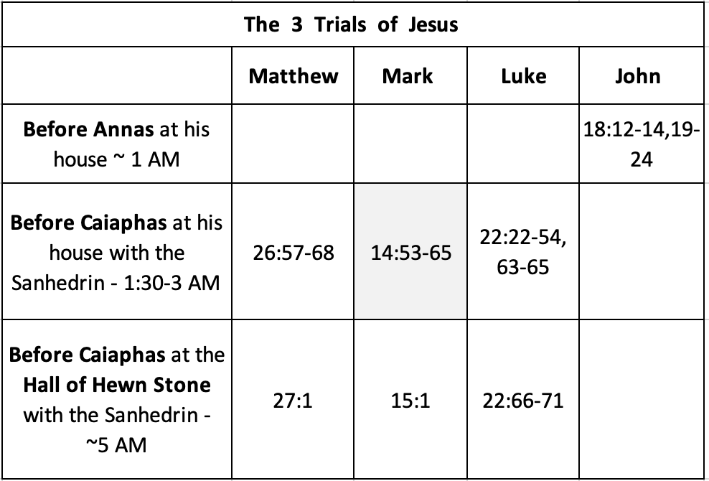

Before Caiaphas at his house:

Part One of the hearing: False Witnesses. v55-59

Part Two of the hearing: False Accusation
v60-64

Psalm 110:1
The Lord says to my Lord:
“Sit at my right hand,
until I make your enemies your footstool.”

Daniel 7:13-14
13 “I saw in the night visions,
and behold, with the clouds of heaven
there came one like a son of man,
and he came to the Ancient of Days
and was presented before him.
14 And to him was given dominion
and glory and a kingdom,
that all peoples, nations, and languages
should serve him;
his dominion is an everlasting dominion,
which shall not pass away,
and his kingdom one
that shall not be destroyed.

Everything is illegal.
The arraignment is illegal.
The testimony is illegal.
The interrogation is illegal, and lastly
The sentence is illegal.

Luke 23:2,
“They began to accuse Him, saying,
‘We found this man misleading our nation and
forbidding to pay taxes to Caesar and saying that
He Himself is Christ, a King.”

Mk 10:33-34
“See, we are going up to Jerusalem,
and the Son of Man will be
delivered over to the chief priests and the scribes,
and they will condemn him to death, and
deliver him over to the Gentiles.
And they will mock him and spit on him,
and flog him and kill him.
And after three days he will rise.”

What is your testimony?

Practice it. Say it outloud. Testify to what God hgas done for you.

Then share the gospel:

- Rom 1:17. God is righteous and glorious.
- Rom 3:23 All have sinned and fall short of that glory
- Rom 6:23 The wages of our sin is death
- Rom 5:8 But while we were sinners, Christ died for us
- Rom 10:9-10 Ifor you confess Jesus is Lord and believe in your heart…. you will be saved
- Rom 10:13 Whoever calls upon the Lord shall be saved.

Discussion and Application

1. Why do people get upset when they perceive that something is not fair?

2. Have you ever been in a situation where normal procedures were set aside
for the sake of expediency? When is this warranted? How was the Sanhedrin
reasoning with regard to expediting Jesus' trial?

3. What was the Sanhedrin looking for in the witnesses who were called? In
what situations do we sometimes look for evidence to support preconceived
conclusions? How do we avoid this error?

4. What was the significance of Jesus' using the phrases “I am” and “Son of
Man" in His answer?

5. Have you ever trusted a friend to defend you and then been disappointed?
Were you able to forgive that person and restore the friendship?

6. In what situations are you tempted to make excuses in order to avoid being
identified as a Christian? Are there other situations where you tend to sim
ply lie low and avoid the subject?

7. Was there a time in your past where you denied knowing Jesus? Was there
a time when you were not confronted, but still you could have spoken up
and did not?

8. Do you feel shame and remorse over situations where you could have stood
up for Jesus? Ask forgiveness from God, go back and correct your witness to that person where possible, and resolve, with God's help, to be courageous
in the future.

9. How were Judas's and Peter's sins similar? How were their responses to guilt
different?

10. How did Peter's experiences on that night prepare him for his ministry?
What experiences have you had that help you communicate grace and compassion to others?

11. Why do you think many are we shy about testifying to Christ and sharing the gospel on a moments notice?

