JUST FOR YOU Colossians 3:20 2-25-2018

Luke 2:41-52 – Jesus Obeyed Col 3:20

Children –“TEKNA” - general term refers to any child still living in the home under parental authority, care and guidance.

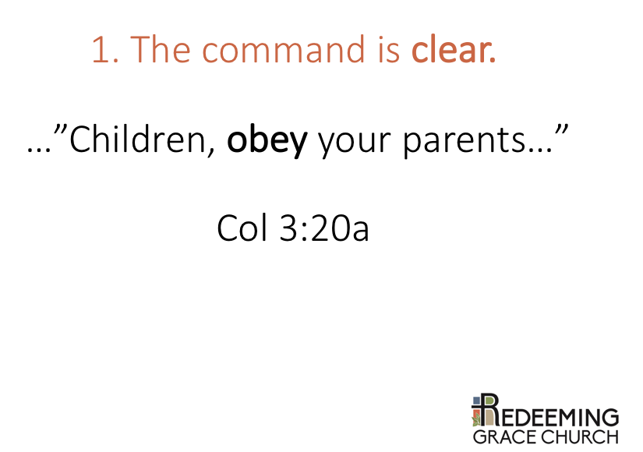
1. THE COMMAND IS CLEAR.

‘Obey’- huoakouete present tense – speaks to a ‘continuous obedience’.

God is serious about children’s obedience:

Striking parent (Exo 21:15) “Whoever strikes his father or his mother shall be put to death.”
Continued disobedience (Deut 21:18-21) punishable by death.
Children are to listen and obey (Prov 1:8)
Proverbs 30:17 consequence for disobedience.
Disobedience marks the ungodly: “disobedient to parents “ Rom 1:30, 2 Tim 3:2

The Lord is unmistakably clear – children are to obey their parents.

2. THE COMMAND IS COMPREHENSIVE
(see next pages)

3. THE COMMAND IS IN THE CONTEXT OF THE LORDSHIP OF CHRIST.
(see next pages)

